A000-Indo-Sumbawa-Ancestor Figure-Wood-20th c

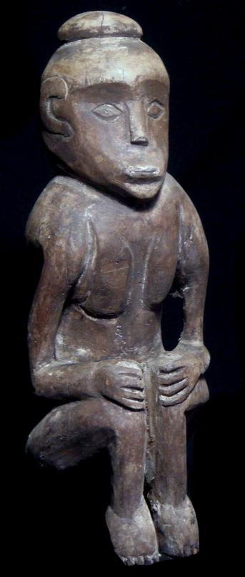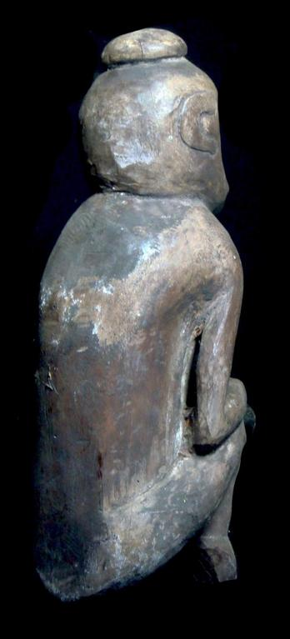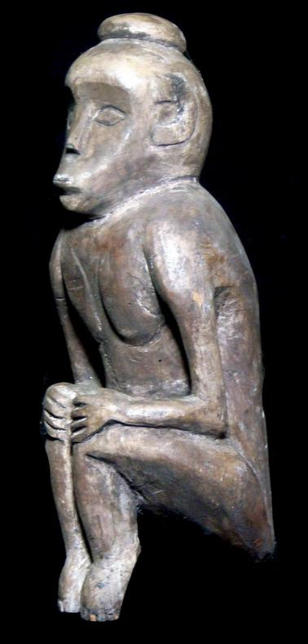

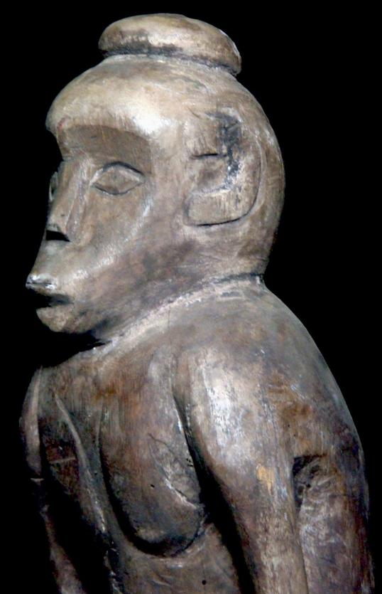

Case No.: Indo

**Accession No.**

**Formal Label:**

**Display Description:**

**LC Classification:**

**Date or Time Horizon:**

**Geographical Area:**

**Map:**

**GPS coordinates:**

**Cultural Affiliation:**

**Media:**

**Dimensions:** size: 37 cm ; 14.5 inches

**Weight:**

**Condition:**

**Provenance:**

**Discussion:**

**References:**